**User Case Diagram - Brent Better**

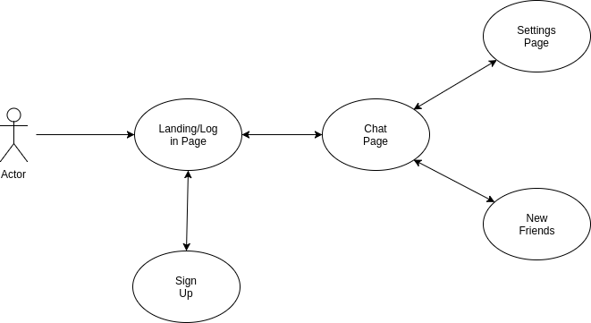

**Activity Diagram - Arjun Chandrasekaran**

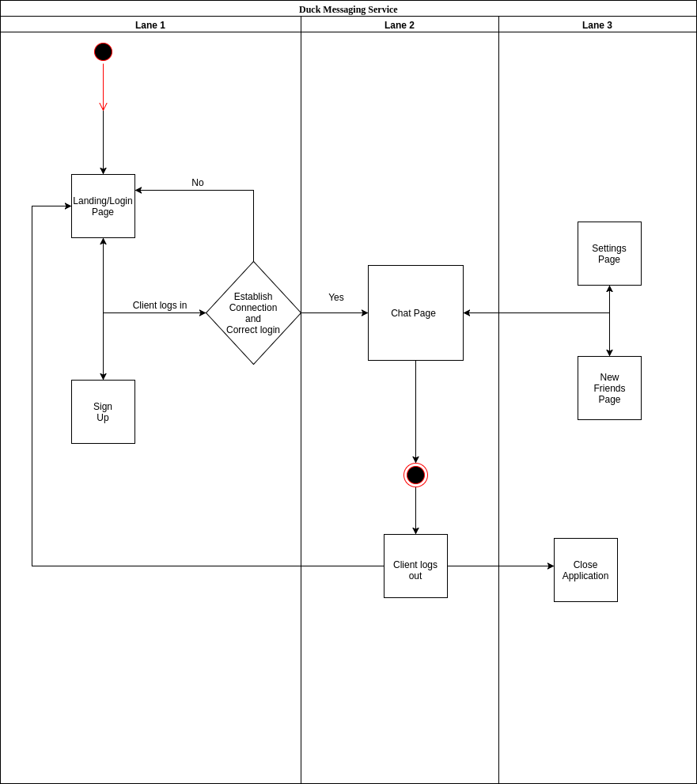

**Class Diagram - Hieu Tran**

